Log Your Strengths
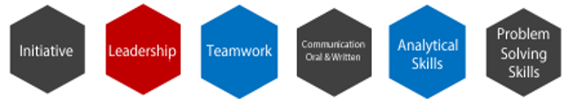

What have I done?  (Projects, Jobs, Service, Initiatives) | What did it take?  (Skills, Qualities, Expertise)

